Evidence for an Imagined Speech-related Event Related Synchronization (ERS)
Abstract
EEG was recorded of subjects performed imagined speech of individual phonemes and analyzed to assess the likelihood that such a methodology might be useful in brain computer interfaces (BCIs). Phoneme conditions were chosen based on articulator class and evidence for an imagined speech-related event related synchronization of cortical neurons in motor and temporal regions is upheld by significant single-trial classification for some subjects but not others. Single trial performance suggests that future imagined speech experiments utilizing feedback to train subjects in the imagined speech task might provide performance on par with modern BCI implementations.

Experiment Methods
64 channel EEG recordings were collected using Advanced NeuroTechnologies Mobile EEG system while subjects performed speaking one of four phonemes in imagination (“Ae”, “L”, “M” and “Z”) and a “relax“ condition in which subjects were asked to sit calmly. The phonemes were chosen based on articulator class and prior work on phoneme-based imagined speech EEG experiments [Xuemin 2011]. Each trial began with the phoneme cue and two clicks separated by 1 s to indicate the time at which the phoneme was to be produced in imagination. That is, imagined speech onset began 2 s after the beginning of each trial (see figure 1 below). Subjects were asked to generate as best as possible both clear auditory imagery and motor imagery while remaining completely still during imagined phoneme production. Each session included 50 trials per condition and 7 subjects participated in 5 sessions, yielding a total of 250 trials per subject per condition.
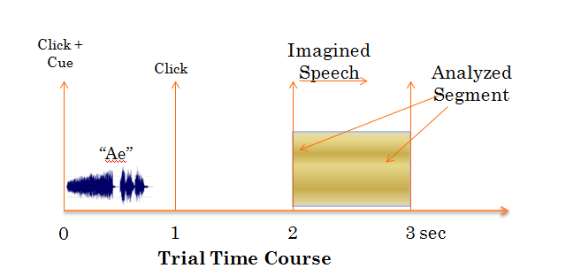
Figure 1 - Trial Time Course. First two seconds contain cue stimuli followed by performance of imagined phoneme.

Classification Methods
Two classification schemes were employed across sessions to assess the ability to discriminate the imagined speech conditions with the EEG data alone. All data was preprocessed with an offline artifact removal scheme designed to remove large correlations in the EEG. The artifact procedure worked as follows: if single trial data exceeded a manually-set threshold then the first principal component was removed and the test was repeated until all data was within the appropriate range (see image below).
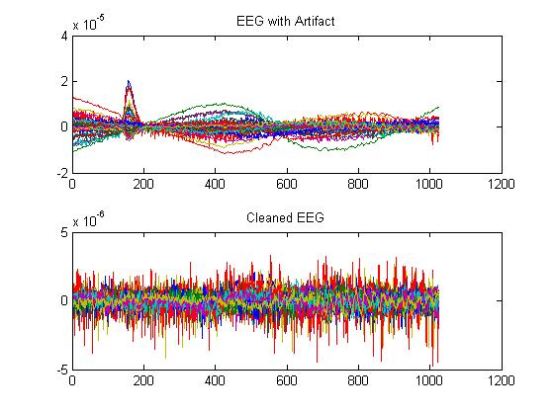
Figure 2 - Artifact Preprocessing. A trial with an eyeblink and muscle movements is cleaned by repeatedly removing the first principal component until all data is within a manually set threshold.

Method 1- Single Channel Classification
The first classification scheme was used to observe the single-trial classification performance of each electrode independently using power spectrum features in the range 1 - 35 Hz. Power spectra were computed using Welch’s modified periodogram using the 1 s period beginning at the onset of imagined phonation. All trials from all sessions were used in a leave-one-out cross-validation analysis using a L2-regularized support vector machine [liblinearSVM, RE Fan, 2008]. For each subject and possible 2-way comparison, single trial classification results for each electrode were plotted as scalp topographies to visualize the relative importance of the 64 EEG channels. The highest single-channel classification result was reported for each comparison and subject. All topographies were created with SSLTOOL)[Deng et al., 2011]. Data was normalized within session; each power spectrum feature was standardized using measurements from only that session.

Method 1 - Single Channel Analysis Results / Discussion
Single trial classifications were performed on a single channel basis and classification rates were compared to the randomized. These sets of random label scores were used as a noise floor to compare and scrutinize the single trial performances and scalp topographies. The mean classification rate of the random labels over all comparisons was .50 and a standard deviation of +/-.025

Results
Classification results were generally not significant for phoneme-vs-phoneme comparisons with 2 exceptions. All phoneme-vs-relax comparisons were significant for 2 of the subjects and some of the other subjects exhibited success in one of those comparisons.
Largest Single-Channel-Classification rates above noise floor for each subject, (phoneme vs relax).
Subject | 1(S1) | 2(S2) | 3(S5) | 4(S10) | 5(S12) | 6(S22) | 7(S24)
Ae | 60 | - | - | 60 | 60 | - | -
L | 63 | - | - | 67 | - | - | 60
M | 64 | - | - | 63.5 | - | - | -
Z | 63 | - | 60 | 64 | - | - | -

Highest Single Channel Classification Result – Random Labels Comparison
Subject | 1(S1) | 2(S2) | 3(S5) | 4(S10) | 5(S12) | 6(S22) | 7(S24)
Ae | 56 | 60 | 56 | 58 | 57 | 57 | 55
L | 56 | 60 | 58 | 56 | 55 | 58 | 55
M | 57 | 59 | 57 | 56 | 56 | 58 | 56
Z | 56 | 58 | 57 | 56 | 59 | 56 | 55

The top 5 electrodes in the phoneme-vs-relax classifications were used to compare effect sizes between the real and random label groups for subjects 1-4
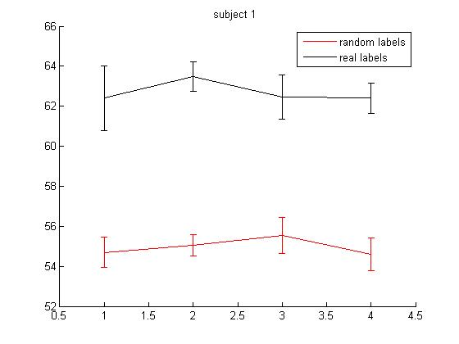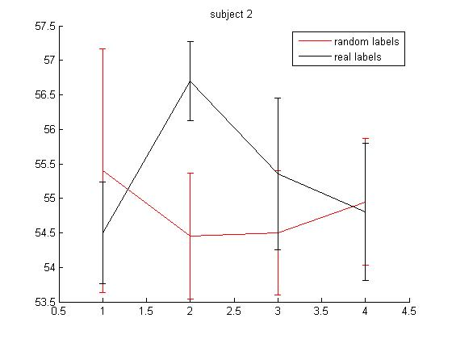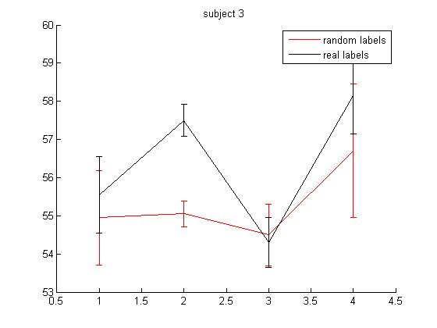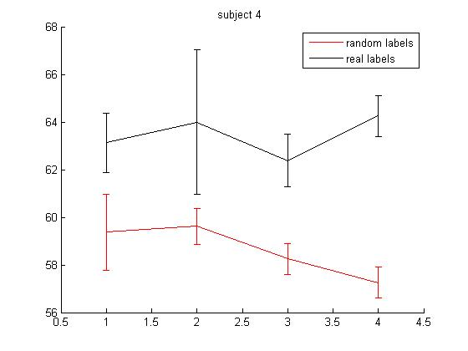

Single-Channel Classifications for all phoneme-vs-relax conditions summed over all subjects. Cortical activity is strongest over motor areas.

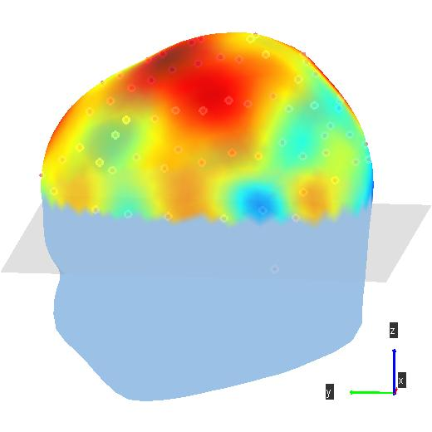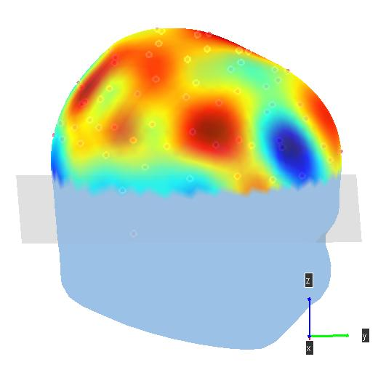

Summed Topos for the 2 highest performing subjects in the single channel analysis (S1 + S10) for all phoneme – vs –relax single channel classifications. Motor and temporal activations are highlighted as well as some parietal activity.

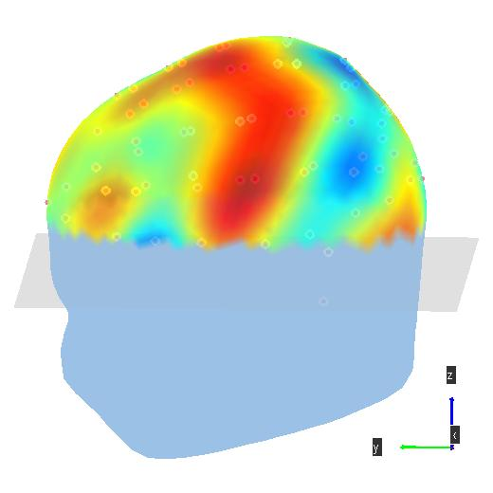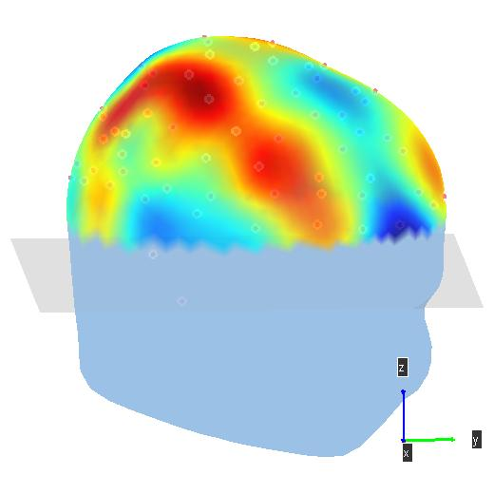

Individual Summed Phoneme-vs-relax Topographies for 2 best performing subjects
Subject 1(S1)
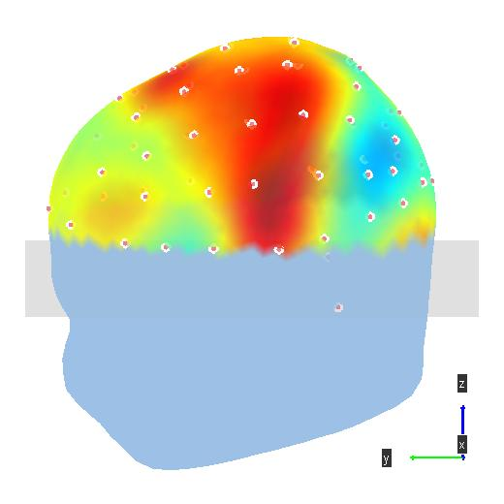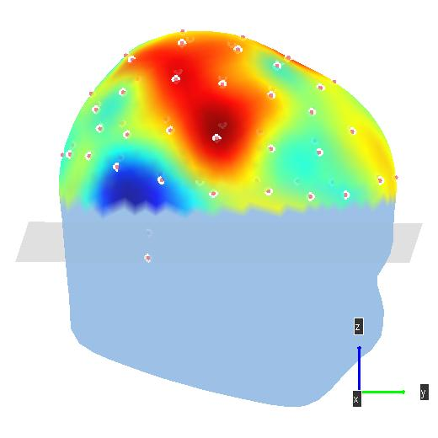
Subject 4(S10)
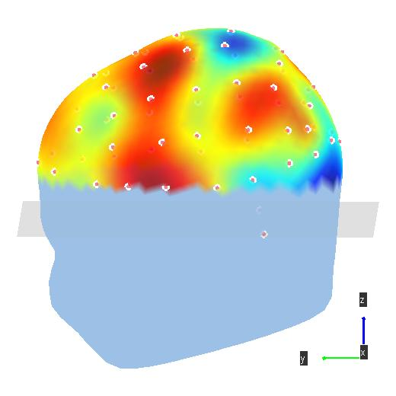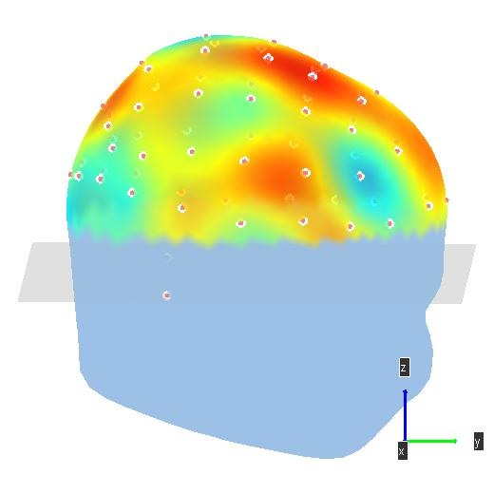

Single Channel topos w frequency spectra and ID of highest performing electrode
Subject 1
Subject 1 Ae vs Relax (60.6)
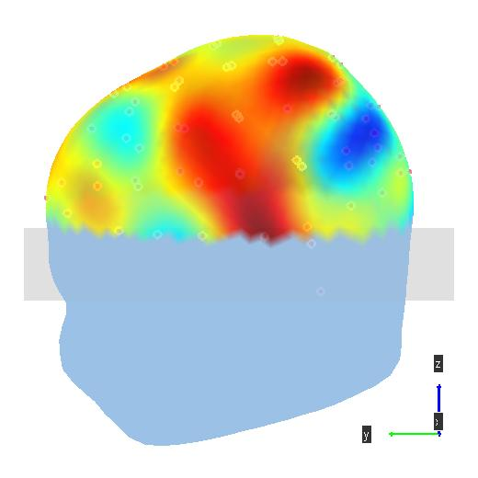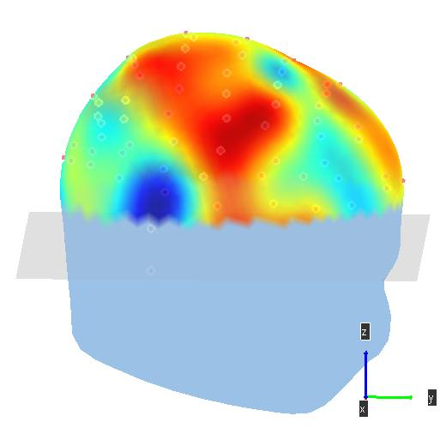
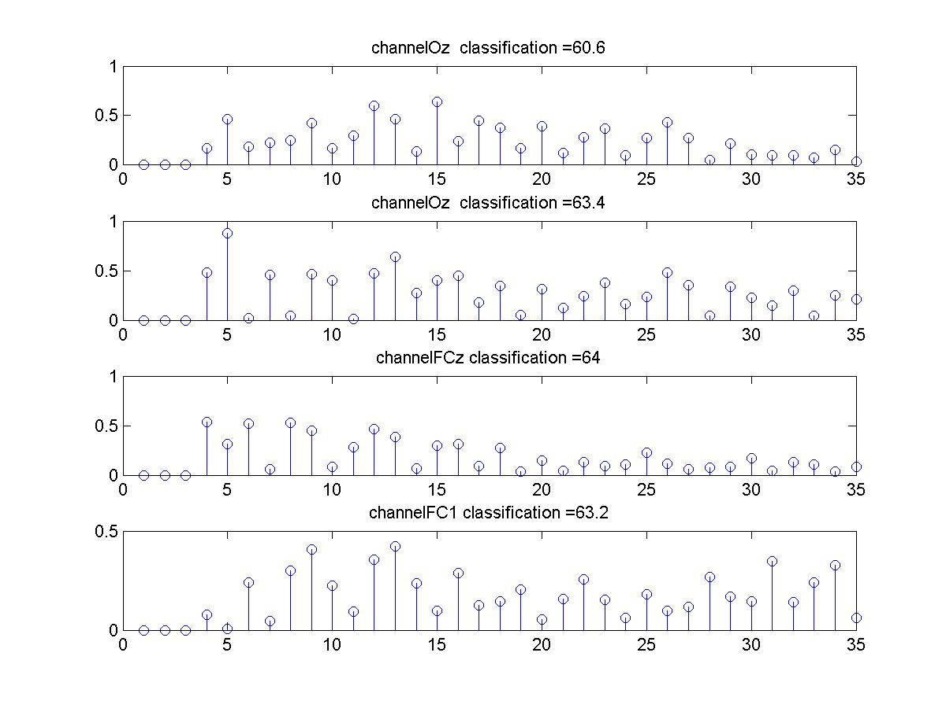

Subject 1 (S1) L-vs-Relax (63.4)
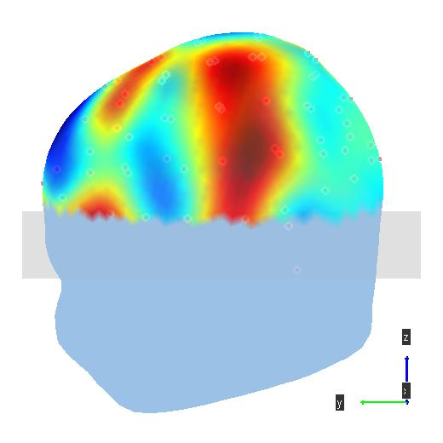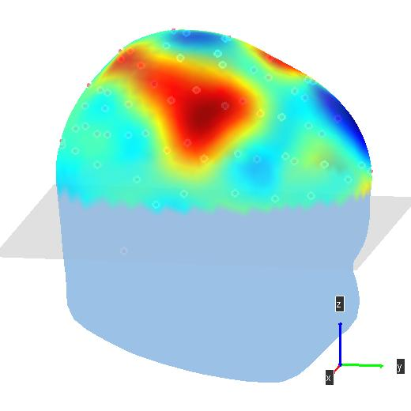

S1 M vs Relax (64)
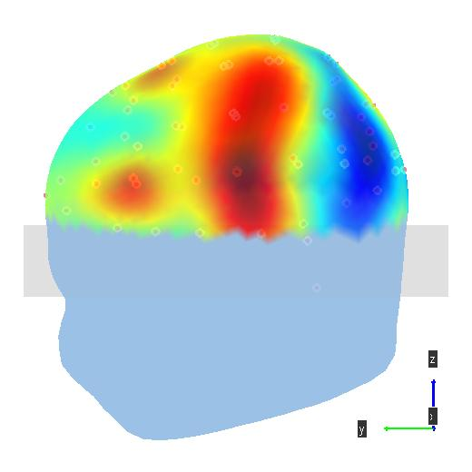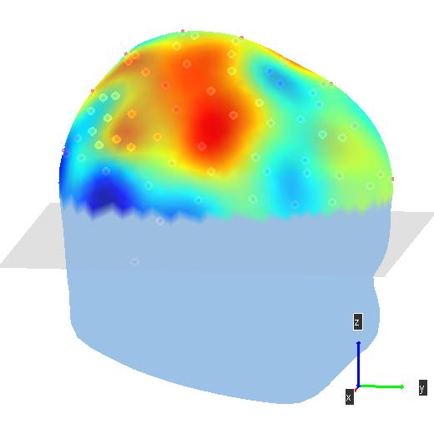

S1 Z vs Relax (63.2)
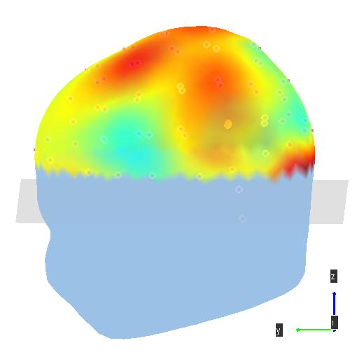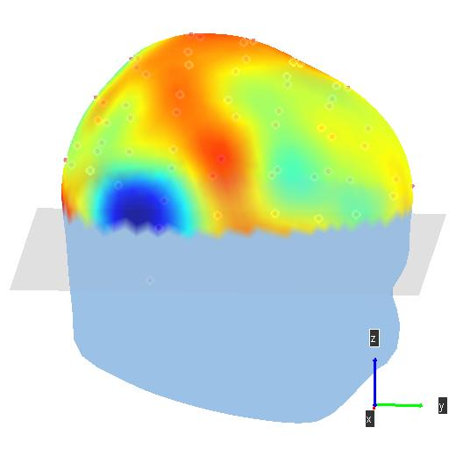

Subject 4 (S10)
Subject 4(S10) L-vs –relax (67)
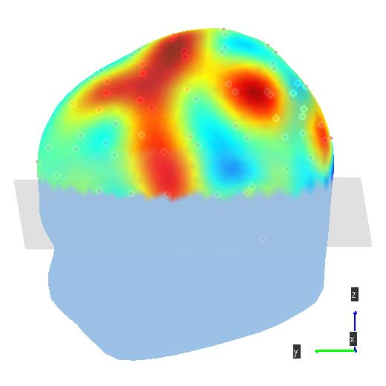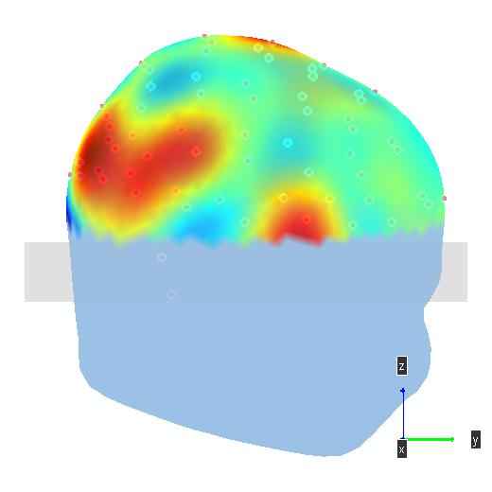
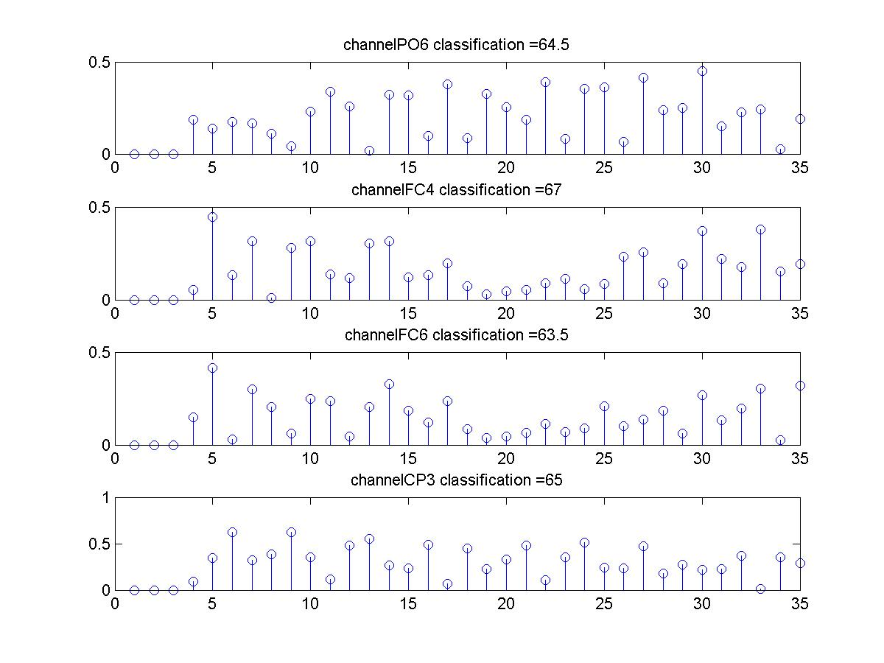

Subject 4(S10) M-vs –relax (64):
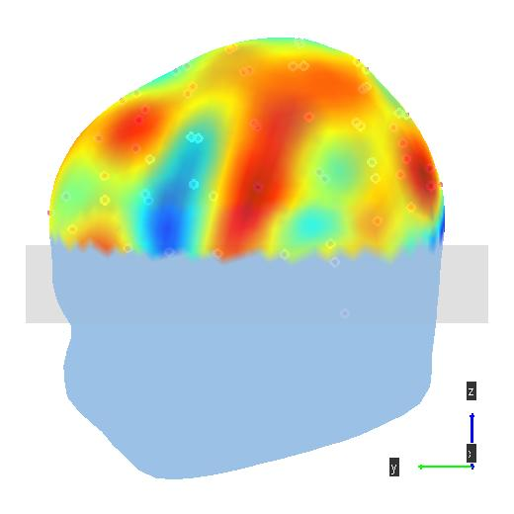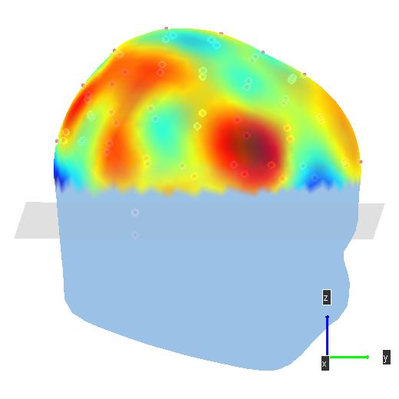

Subject 4(S10) Z-vs –relax (65):
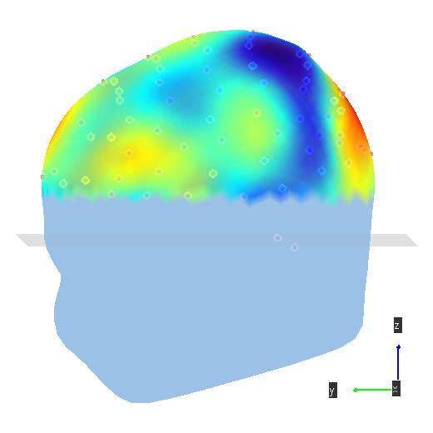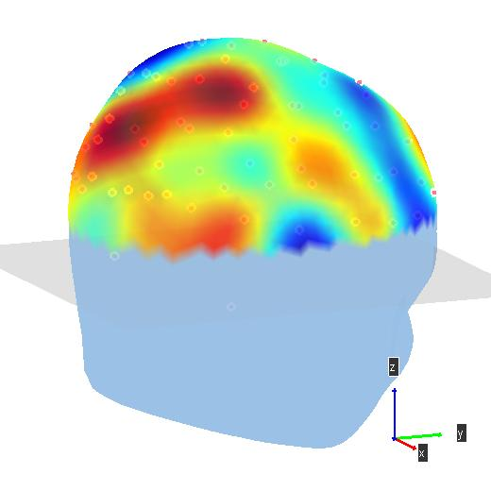

Random Label Topographies for 3 highest single channel classifications – activations do not appear significantly in any one region
S2 – Ae vs Relax (60)
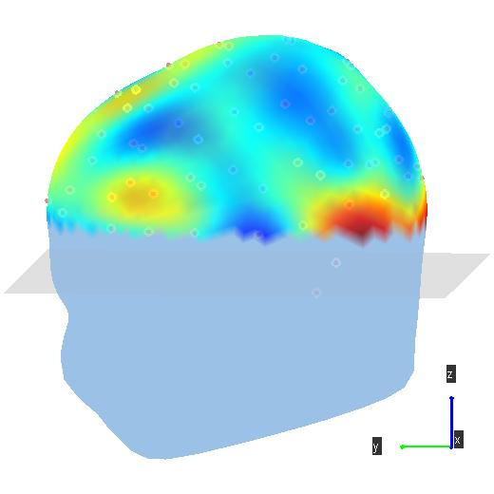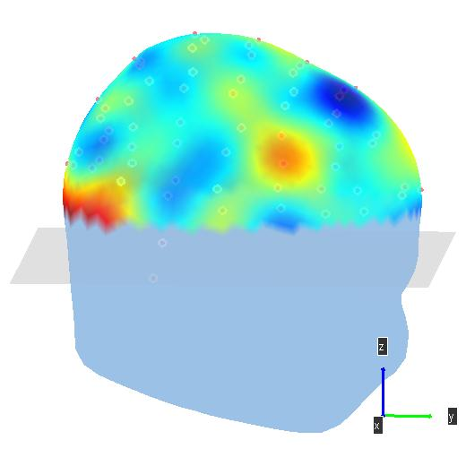
S2 – L Vs Relax (60)
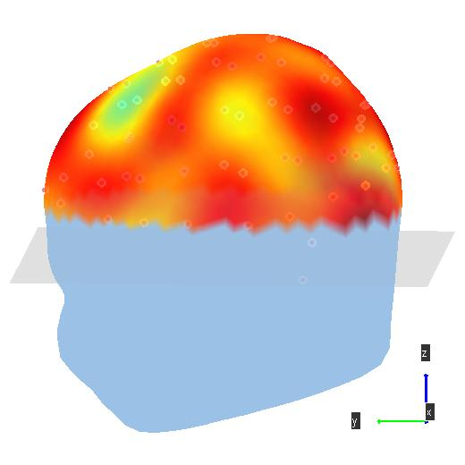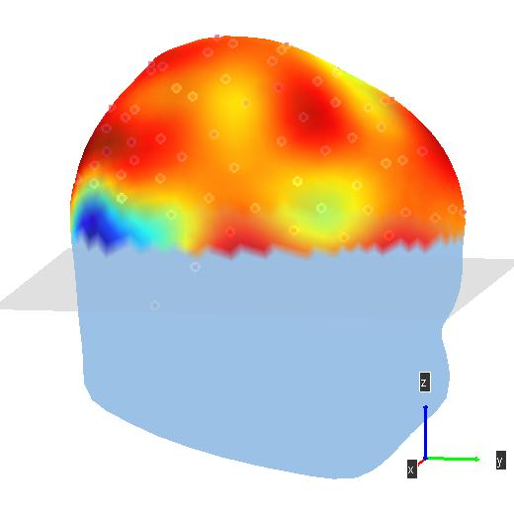
S10 Ae vs Relax (58)
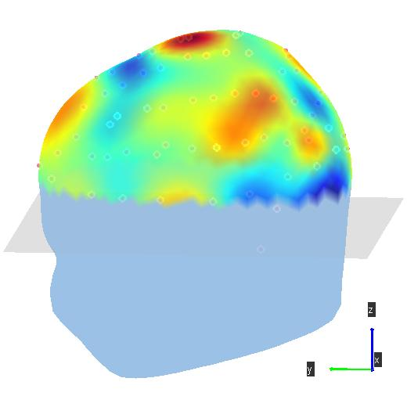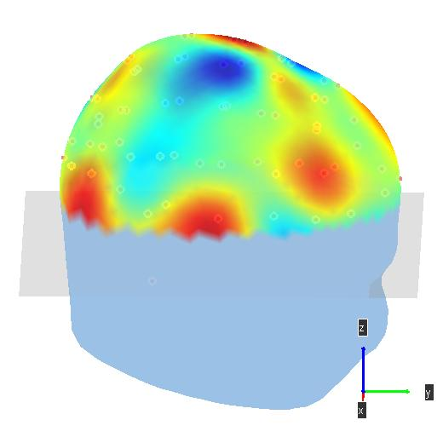
Method 2 - Component-Wise classifications
In the second classification approach, the EEG was projected onto estimated components and then power spectra taken as features of the data-reduced projections. The component methods used were principal component analysis (PCA)[XX XXXX], independent component analysis(ICA)[Sejnowski et al, 199X ] and stationary subspace analysis (SSA)[Muller et al., 200X]. Components were estimated using EEG from the 1 s period beginning at imagined speech onset. The top 15 components were retained for each method and power spectrum features taken of each component projection. Each trial from each session was used in a single trial classification using the L2-regularized support vector machine. The regularization provided by the use of a L2 norm restricted the weight growth of highly correlated features [liblinearSVM]. To create scalp topographies each component was weighted by the linear classifier weights assigned to it’s features in the comparison. The 15 weighted component projections were then summed to produce a single topography for each subject, comparison and component method. Session data was normalized by removing the mean of each feature in a given session…
As in method 1, random label classifications were performed and the noise floor was set with a mean of .50 and standard deviation of +/- .03. These results were slightly higher than the first approach likely due to the larger feature set in each comparison.
Method 2 - Component-Wise Classifications Results
Highest component-wise classification rates (over all component methods) above noise floor for each subject, (phoneme vs relax).
Subject | 1(S1) | 2(S2) | 3(S5) | 4(S10) | 5(S12) | 6(S22) | 7(S24)
Ae | 68 | - | 60 | 68 | - | - | -
L | 71 | - | 61 | 67 | 60 | - | -
M | 72 | - | - | 67 | - | - | -
Z | 66 | - | - | 67 | - | - | -

The two subjects who exhibited highest success in classification method 1(Subject 1 (S1) and Subject 4 (S10)) also performed best in the component comparisons.

Individual Topographies – Phoneme Vs Relax Comparisons
'S1'
Ae vs relax – PCA 68
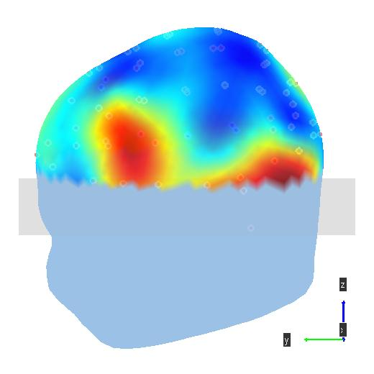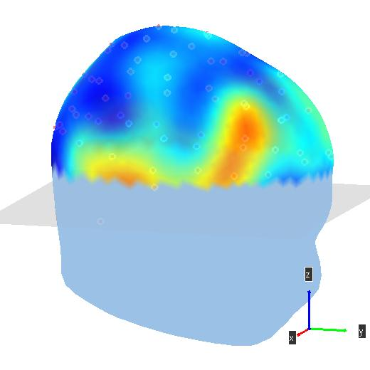
L Vs Relax – ICA (71)
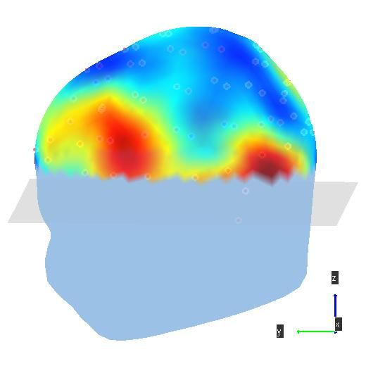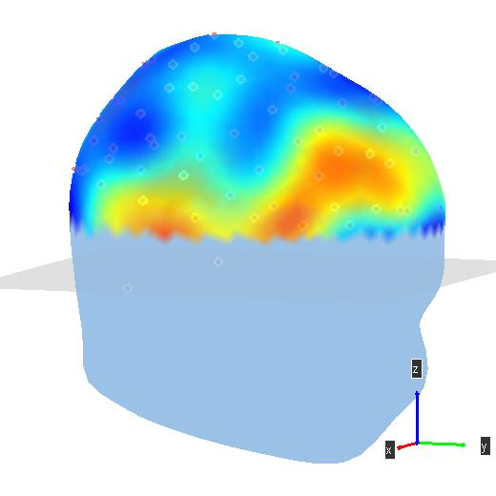
M vs Relax – 72 - ICA
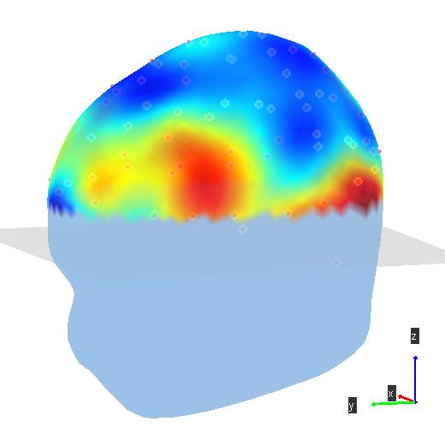
Z vs Relax – 66 PCA
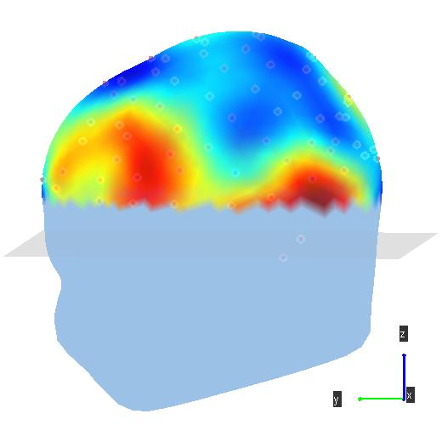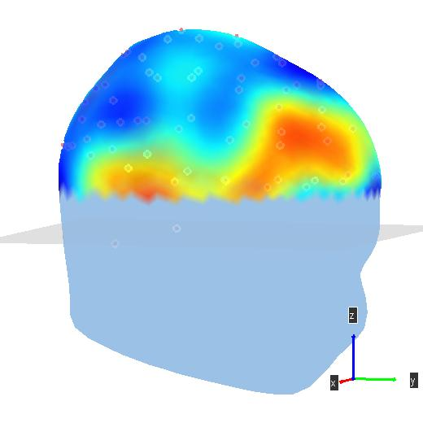

'S10'
Ae vs Relax – ICA (%68)
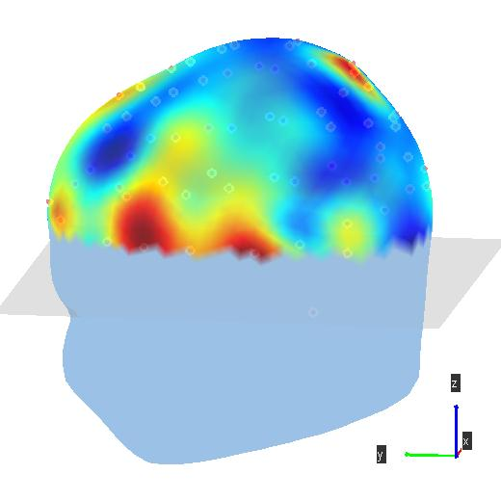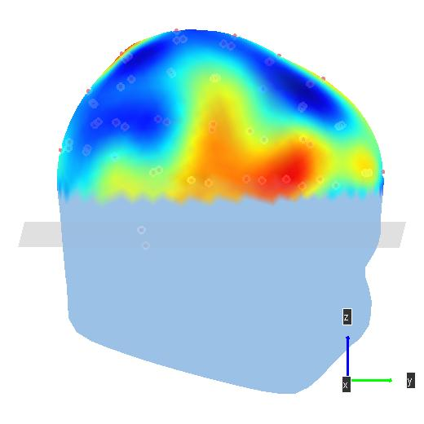
L vs Relax – ICA 67
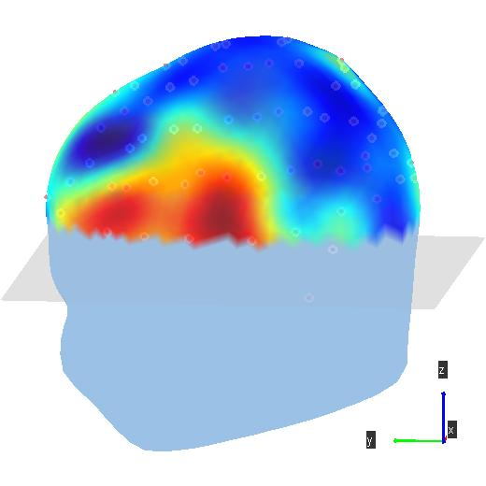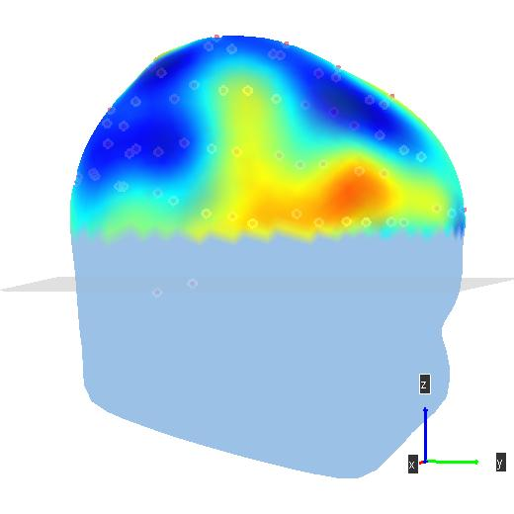
M vs Relax – ICA 67
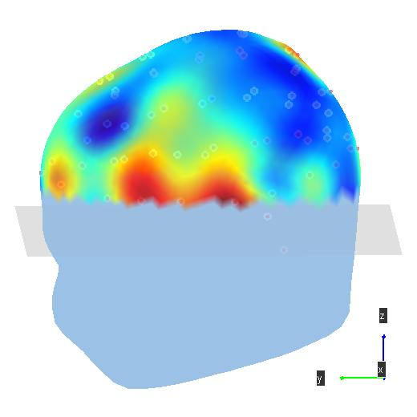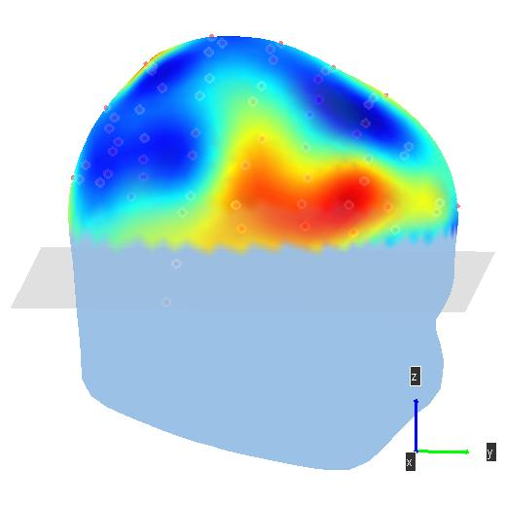
Z vs Relax – PCA – (67)
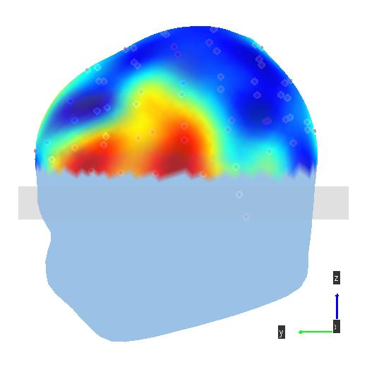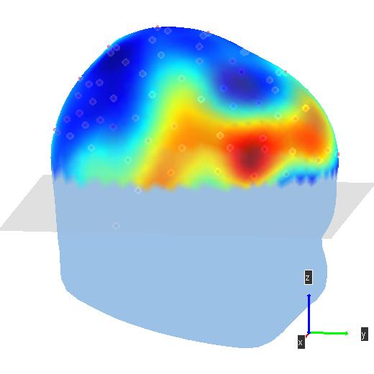

'S12'

L vs Relax PCA (60)
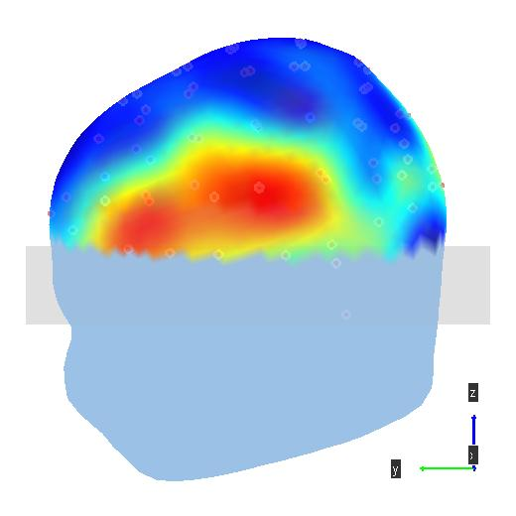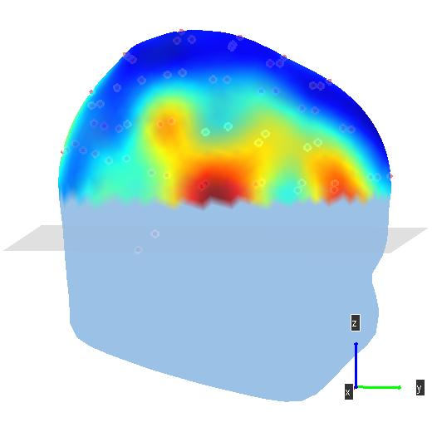

'S5'
Ae vs relax ICA
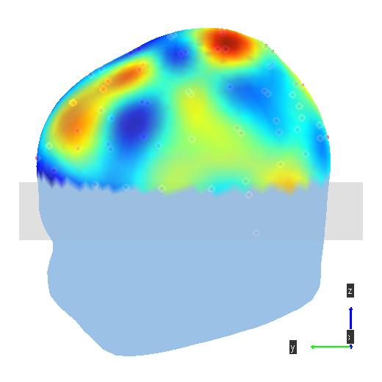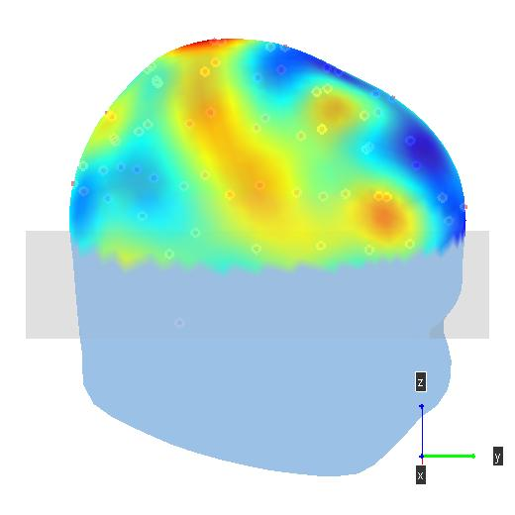
L Vs Relax – PCA - 61
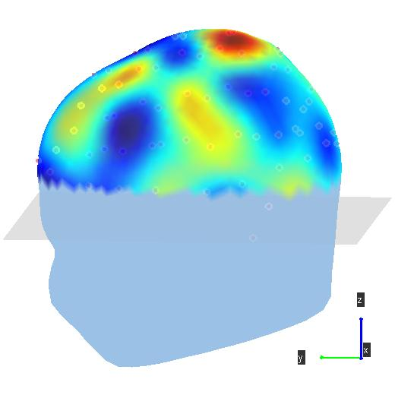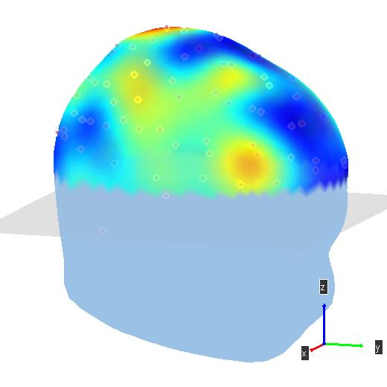

Highest Phoneme-vs-phoneme classification rates above significance.
Subject/Comparison | 1(S1) | 2(S2) | 3(S5) | 4(S10) | 5(S12) | 6(S22) | 7(S24)
 | 63 – (M vs Z) | - | - | 61 (L vs M) | - | - | -

Phoneme vs Phoneme Topos

S1 – M vs Z ICA (63)

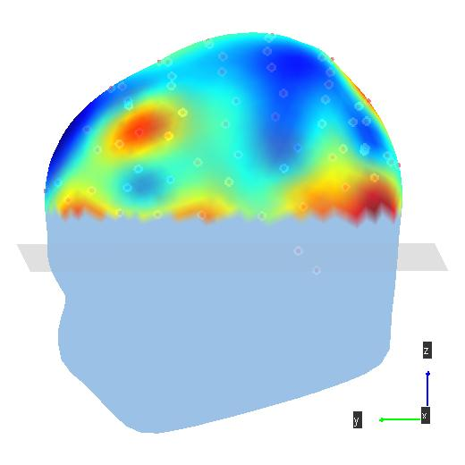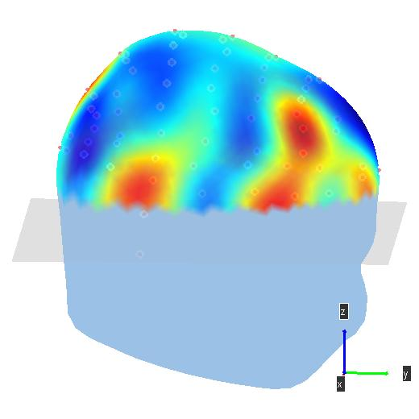
S10 – L vs M PCA (61)
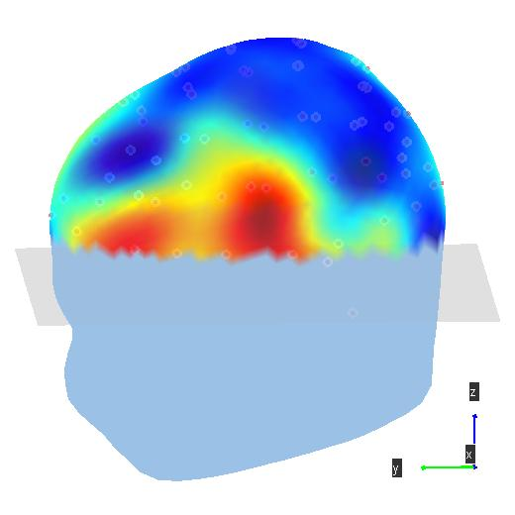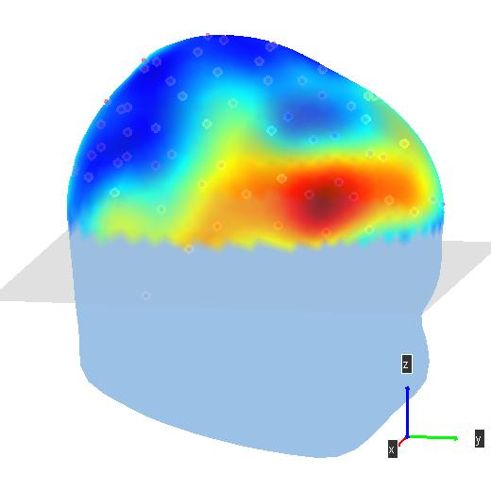
Discussion/Conclusion/Future Work

Certain subjects exhibited significant EEG differences over different conditions and those signals arose from cortical locations relevant to imagined speech – temporal and motor areas. The articulatory networks for speech as outlines in [Hickok, 2012] (see image below) appear in many of the phoneme vs relax and phoneme vs phoneme topographies presented above. Of the 2 best performing subjects one reported having used nicotine lozenges and the other had significant experience in performing imagined speech experiments. These results also support the possible success of future imagined speech experiments using feedback to train subjects best perform individual imagined speech phonemes such that between-phoneme comparisons are maximized.
These results indicate that imagined speech does modulate cortical neurons in relevant speech areas, though single trial classification performance is not yet suitable for BCI applications. This might be due to lack of instruction in the task or variations in their cortical surface geometry – which has also loosely been named ‘BCI illiteracy’.

